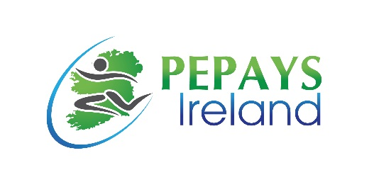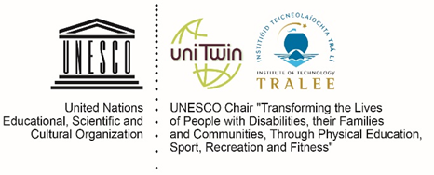
ABSTRACT Submission Form
DEADLINE April 5pm Monday April 18th 2016: ACCEPTANCES notified w/c 25th April
PEPAYS Ireland Annual Forum 2016
30TH May 2016, IT Tralee, Tralee, Co. Kerry
“Charter for Change”

Name(s):__________________________________________________________________________________
Organisation: ______________________________________________________________________________
Position(s):________________________________________________________________________________
Email address(es): ________________________________ Phone Number(s):__________________________
Please tick: Oral _____ or Poster Presentation _____
Title of Abstract: ____________________________________________________________________________________________________________________________________________________________________________________
Abstract (no more than 250 words (excluding references) describing your project in terms of objectives, methods, results /outcomes and conclusions). Font either: Calibri/ Arial Minimum Size 11. Line: Spacing Maximum 1.5. Please submit to unesco@ittralee.ie. Please tick one theme choice below:
1. Physical Education, Physical Activity and Sport as a Fundamental Right for All ______
2. Benefits of Physical Education, Physical Activity and Sport______
3. The Need for Strategic Vision on Policy Priorities Across all Stakeholders______

